Rotary Club of Dhulikhel
Report for the month of August 2026
Club News and Activities

Title (4-7 Words): | United for Bhotekoshi Flood Relief
Club Name: | Rotary Club of Dhulikhel Club no 50576
Event Date: | 27 August 2026
News (100-250words)  - Specialty  - Facts & Figures  - Budget  - Beneficiary Profile  - Impact/Outcome | Rotary District 3292 organized a Disaster Relief Coordination Meeting in response to the loss, damage of life and property caused by flooding in the Bhotekoshi River on 26 August 2026.International Service Chair Rtn. Ashok Kumar Shrestha of Rotary Club of Dhulikhel and Honorary Member Rtn. John Price of Rotary Club of Edwardstown, Australia, participated in the coordination efforts.  The meeting highlighted the importance of immediate disaster relief, long-term recovery, rehabilitation, and reconstruction, along with effective resource mobilization and volunteer coordination.  Rotary District 3292 appealed to Rotarians, Rotaract Clubs, partners, and well-wishers to support relief, reconstruction, and rehabilitation efforts.  Through Service Above Self, Rotary remains committed to supporting affected families and communities and contributing to sustainable recovery and reconstruction in the affected areas.
Do not write/edit/correct anything on shaded space and attach picture separately.

Written by: Rtn. Ashok Kumar Shrestha, International Service Director, 2026-27
Checked & approved by: Rtn. Mohan Kumar Shrestha, President 2026-27
Submitted by: Rtn. Nilopher Shrestha, Secretary 2026-27
Date: 27 August 2026

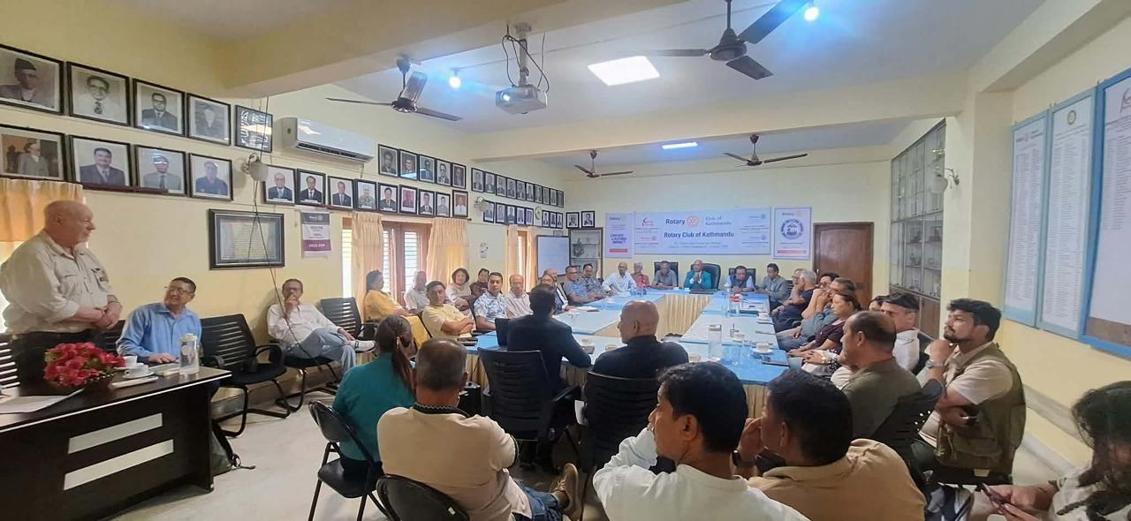

Title (4-7 Words): | Mobilizing Hope for Bhotekoshi Flood Victims
Club Name: | Rotary Club of Dhulikhel Club no 50576
Event Date: | 30 August 2026
News (100-250words)  - Specialty  - Facts & Figures  - Budget  - Beneficiary Profile  - Impact/Outcome | When disaster strikes, the true strength of a community is seen in the hands that reach out to help.  Following the devastating floods along the Bhotekoshi River, the spirit of Rotary partnership and service came to the forefront. Australian Rotary volunteers joined hands to extend timely assistance and bring much-needed relief to families affected by the disaster.  As part of this relief effort, 100 blankets along with essential supplies including 25pc of tarpaulin, 20 foam mattresses, 25 sets of plastic rope, 100 dinner plates, and 20 HD buckets, clothes were handed over to Rotary International District 3292, District Governor Rtn. Vishnu Bahadur Karki.  This timely assistance reflected the spirit of Rotary partnership and its continued commitment to standing with vulnerable communities and providing support during times of crisis.  Meanwhile, Few Rotaractors from Kathmandu University (KU) and Kathmandu University Medical School (KUMS) are mobilizing and closely tracking relief efforts toward Rasuwa to help ensure that assistance reaches affected communities in a timely and coordinated manner.

Do not write/edit/correct anything on shaded space and attach picture separately.

Written by: Rtn. Ashok Kumar Shrestha, International Service Director, 2026-27
Checked & approved by: Rtn. Mohan Kumar Shrestha, President 2026-27
Submitted by: Rtn. Nilopher Shrestha, Secretary 2026-27
Date: 27 August 2026

